Casa Sul Parco: Application of Active House vision for apartments
by Petra Pálfi - 2 days ago - News
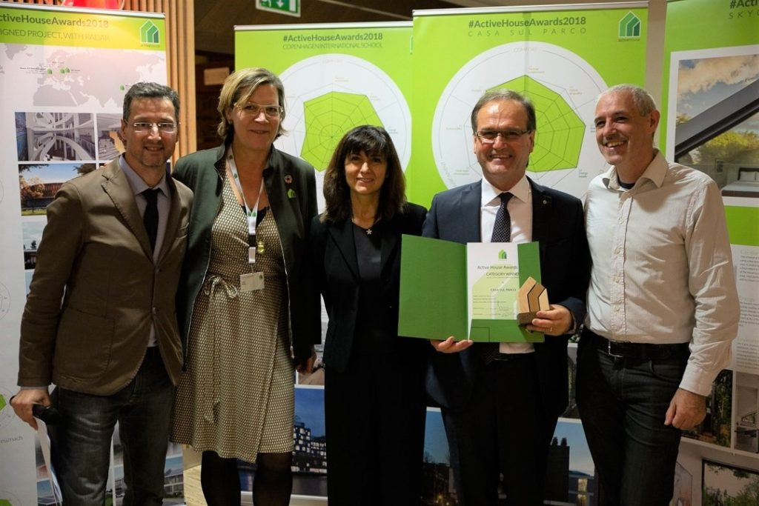
Casa sul Parco is an apartment project in Fidenza, Italy designed by architects Studio del Boca & Partner and Giovanni Rossi & Partners. The developer is Montanari Costruzioni. The project won an Active House Award at the 2018 Active House Symposium. Below Günther Gantioler answers a few questions on behalf of the Casa sul Parco project.
Your project won an award at the Active House Awards this year, congratulations. Why did you submit your project for the Active House Awards?
„We submitted the project „Casa sul Parco“ convinced of its quality and beauty. We also hoped to win an award. Awarded projects are chosen by an external, international, unbiased jury. This allowed us to test if the project could fulfil these high requirements. Honoured with the award, we are firstly very proud of it, but secondly, we believe it is important at the national level as it shows our Italian architects and constructors, what can be done when everyone does their best.“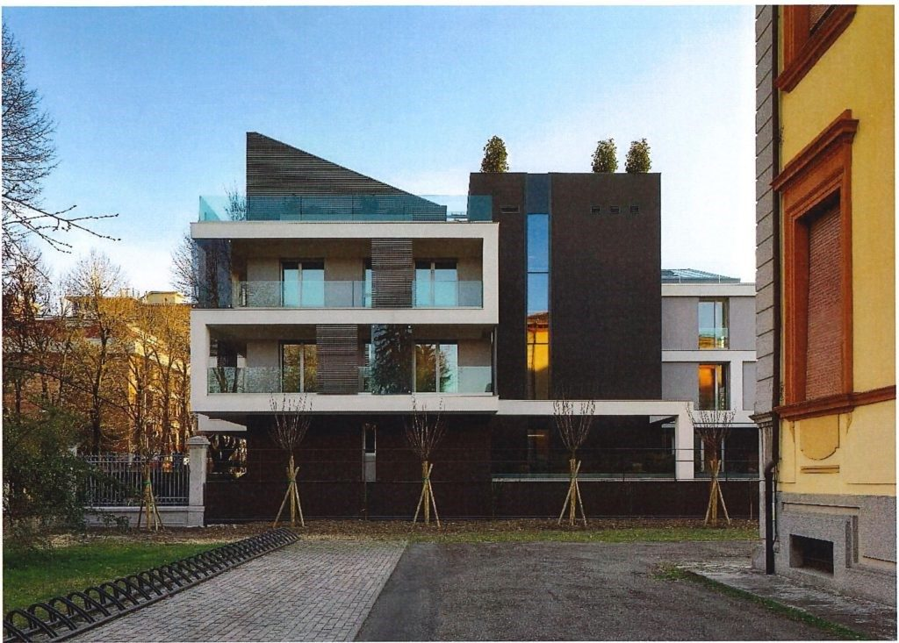
What does winning the Active House Award mean for your project/organization? What would you say are some of the key features that make Active Houses better buildings?
„The Active House Award means for us, and for Montanari Costruzioni that designed and built the building, that you can accomplish anything if you have a great team which collaborates in a professional way. The quality, quantitative aspects like energy consumption or natural light, together with qualitative aspects like beauty or functionality must be recognized not only by experts but also by normal people, that want to buy an apartment and have to choose between many proposals on the market. The Active House Standard supports us in improving overall quality. In the radar, it gives us an easily understandable communications tool showing the different quality aspects. “
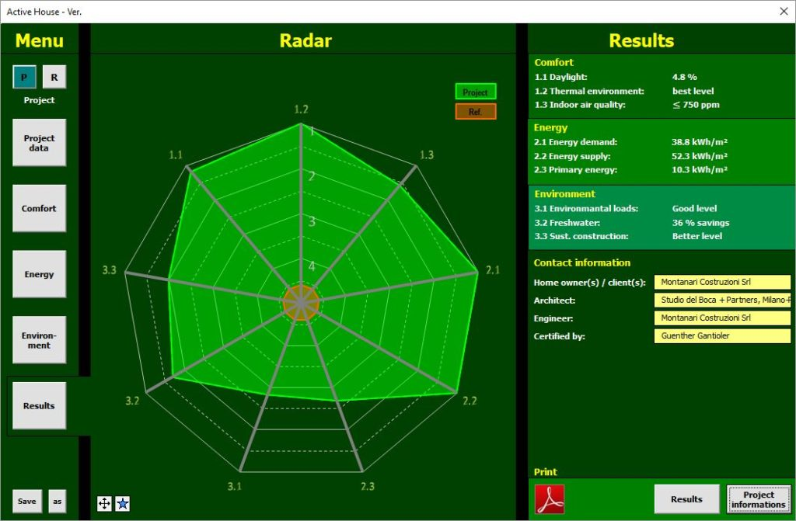
At this year’s symposium, there was a lot of talk about digitalisation and technology changing our buildings. How does your project use these?
„As many modern buildings, Casa sul Parco is a Smart Home with advanced home automation (automatic control of temperature, humidity, light, shadings, remote control of technical installation), visualization (remote cameras of inside/outside, visualization and monitoring of main comfort parameters like temperature, humidity and CO2-level), security (advanced alarm and intrusion control), and much other installed on an KNX-BUS-standard. Furthermore, maintenance is highly pre-programmed for the next decade. While digitalisation has many positive elements, it should never become predominant and overwhelm our customers. For this reason, we should also be careful and use only reliable technologies. “
How do you think we can convince more people of the importance of healthy buildings? How does your project address this important aspect?
„The Italian Po-plains is one of the areas in the world with the highest levels of air pollution. We addressed this issue by deciding that reduce air pollution inside the apartments we made good air-tightness (passive house level) together with mechanical filtered air ventilation. This was one of the key decisions our project. In any case, healthy living like healthy food is very important for our customers in Italy. “
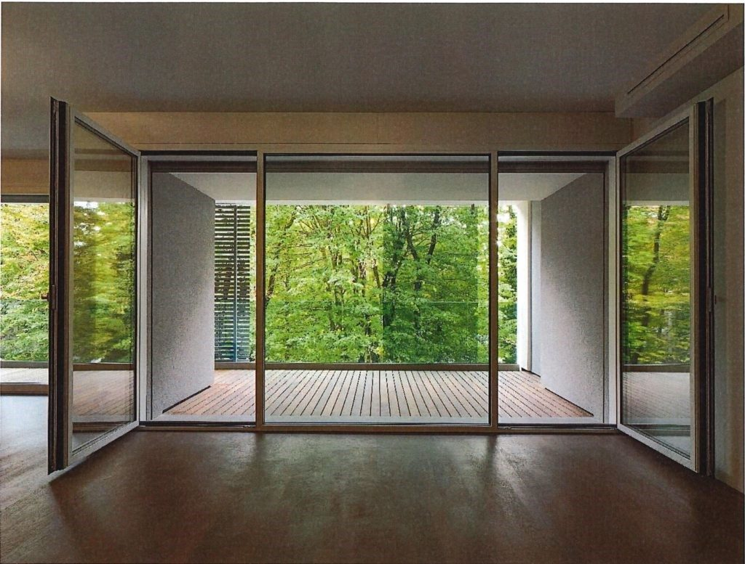
Active House is all about comfort, energy, and environment. How does your project incorporate these aspects?
„Let us begin with the easiest point: energy. On the energy side, we wanted only the best, so we have chosen the passive house standard. We have however on the renewable element a weak point because the landscape protection bans the possibility of installation of PV or thermal solar plants. For the future, we planned a PV-plant outside the city, but it was not taken into account for now.
To address the other elements, comfort, and environment, the Italian Passive House Institute recommend Active House and so we checked the details on this, for us, the new standard.
High comfort and high indoor air quality standard were achieved nearly automatically with the Passive House Standard. But natural light was a little bit tougher because in the hot Italian climate it doesn´t make sense simply put more windows on the facade. This would also increase overheating. Fortunately, our architects nearly from scratch made a smart adapted architecture fit for the local climate. So, when we tested it with the radar results, we easily found the best way.
Water saving is mandatory in our location, so also this requirement was fulfilled easily. However, the sustainability part was very challenging. In Italy, we miss much of the information about the life-cycle of the used materials. Only international companies sent us their EPD´s. We hope that in the future we can convince our suppliers to make a life cycle assessment of their products to make this easier in the future. I think Active House is also important for this purpose: putting pressure on the companies to make LCA´s of their products. “
If you were to give one piece of advice to next year’s contestants, what would it be?
„Our advice is to improve documentation during the construction process (photos, calculations, …) to ensure results and a good complete documentation for the jury. To Active House Alliance I would suggest a feedback-round from the jury to the contestants. This could eliminate misunderstandings.“
You can read more about the Casa sul Parco project here.

